# React Essentials-Components, JSX, Props and State

## Components:

Components are UI building blocks. They are the reusable building blocks which a react developer can create and which is then combined to build the overall user interface.

***The react apps are build by combining components.***

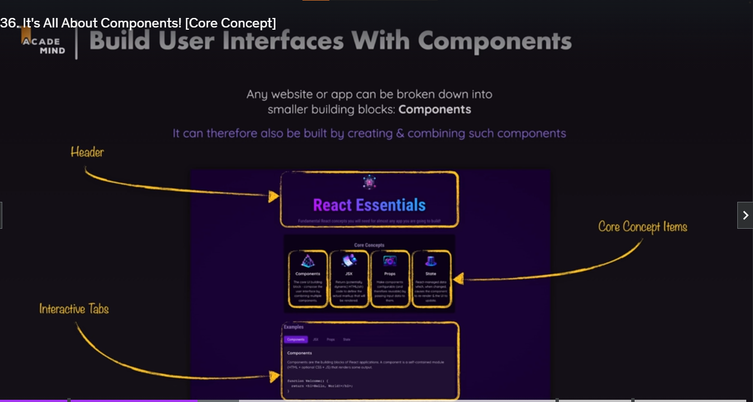

The components are created by wrapping the HTML, CSS and Javascript codes defines the part of the UI. This allows the developer to split up complex user interfaces into smaller and manageable parts, which can be reused in different places.

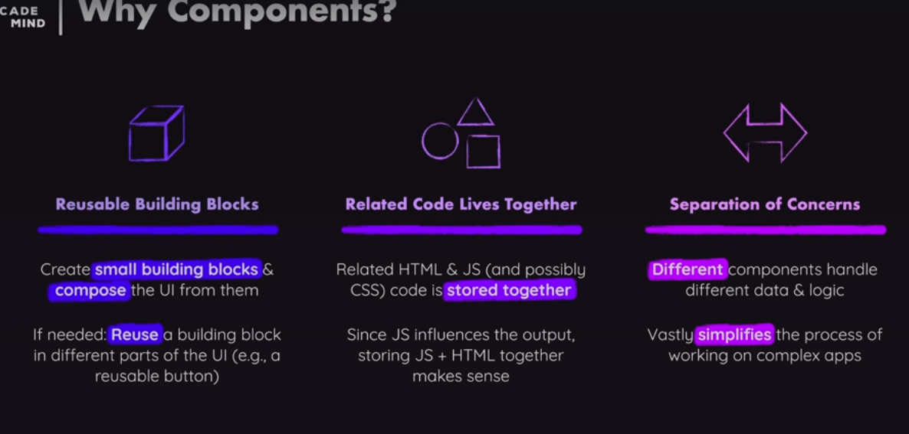

## JavaScript Syntax Extensions

This extension allows developers to describe and create HTML elements, by writing HTML markup code inside of java script files. Since, react is about describing and creating user interfaces, this is a very useful feature.



This .jsx is not supported by the browsers. Instead, the code written is transformed behind the scenes by the development servers before it reaches the browser.

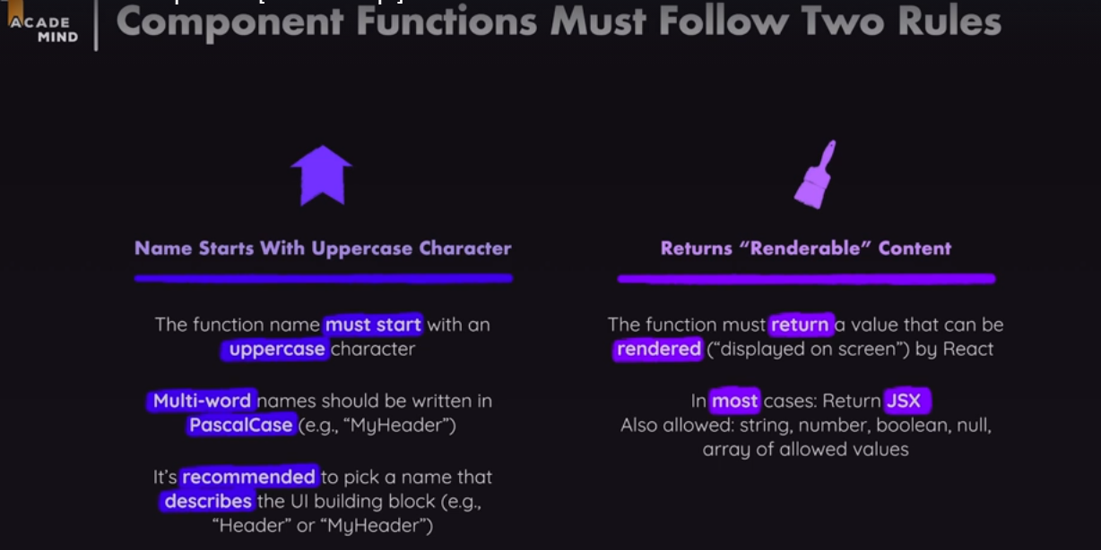

## Making Components Reusable with props

The main advantages of components are they are reusable.



There is another crucial concept that is related to components which is known as **props.**

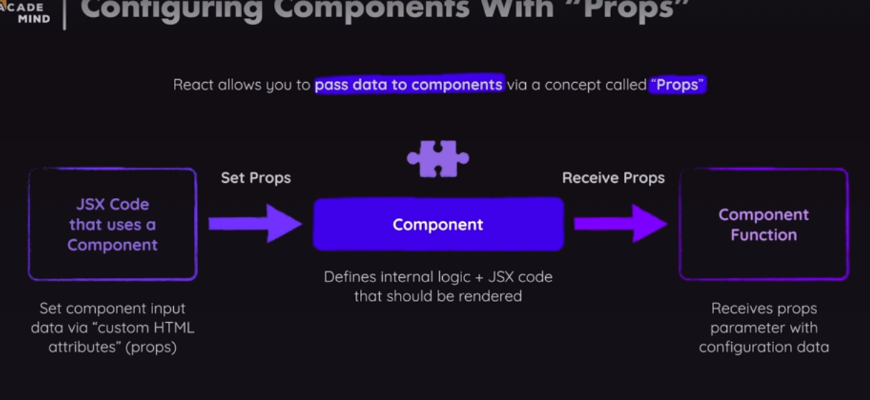

The concept of prop is being able to pass data into components and then to use them.

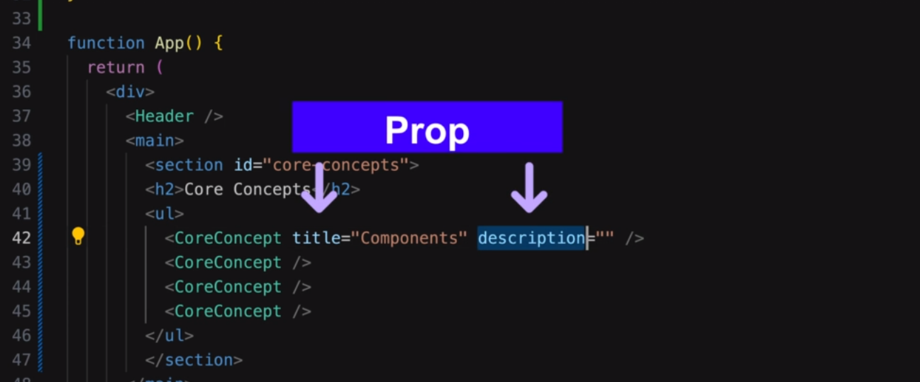

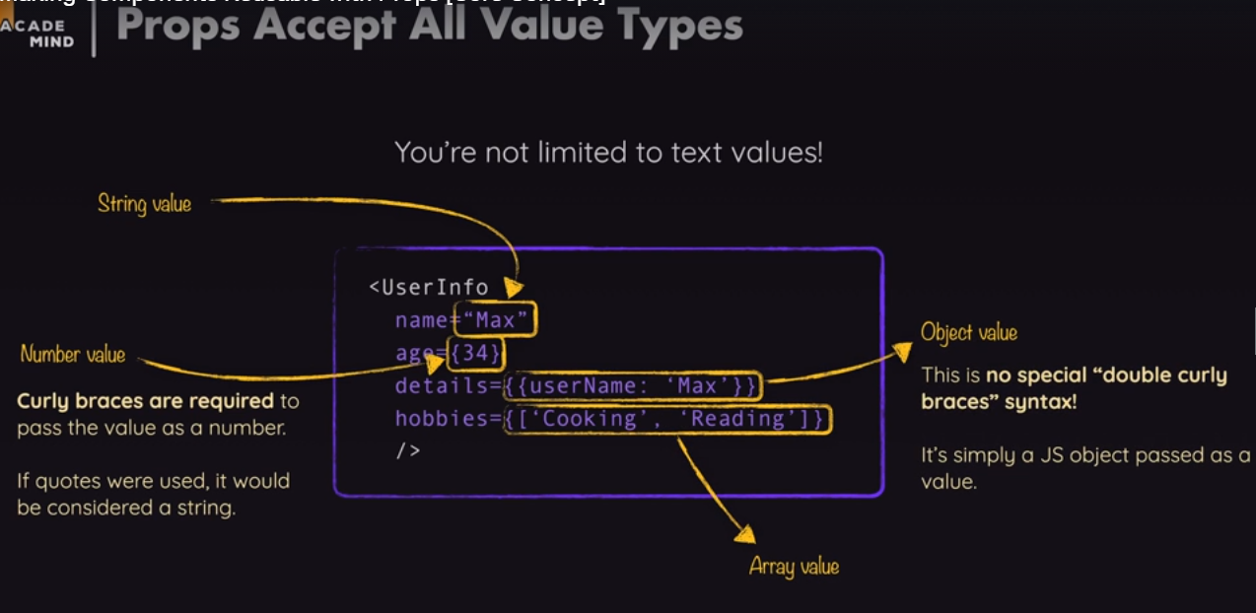

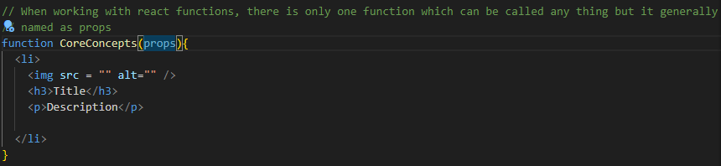

The overall react concept is known as the props, therefore, the name is given as props in the **CoreConcept** parameters. The **props** parameter will be set by react, because the react will execute the function **CoreConcepts.** The developer is not calling the component functions by themselves in the code. Rather, they are used as the HTML elements and under the hood react calls the actual functions. Therefore, react passes a value for the given props parameters to the function when it calls it and the value that will be passed for this function will be an object. It will be an object that has the value of the props in the form of key value pairs.

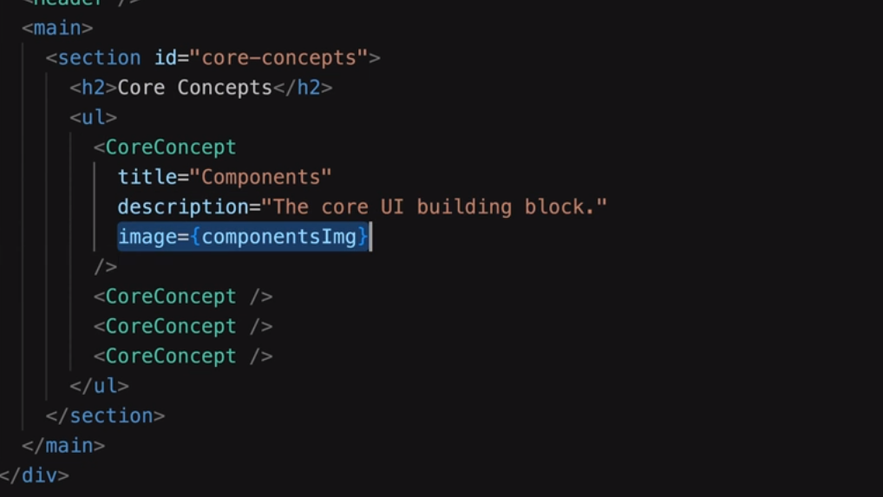

In the given figure, the *title is the key*  and its corresponding value is the “*Components”.* Therefore, the custom attributes acts as keys and the values for this keys are grouped as *values.*

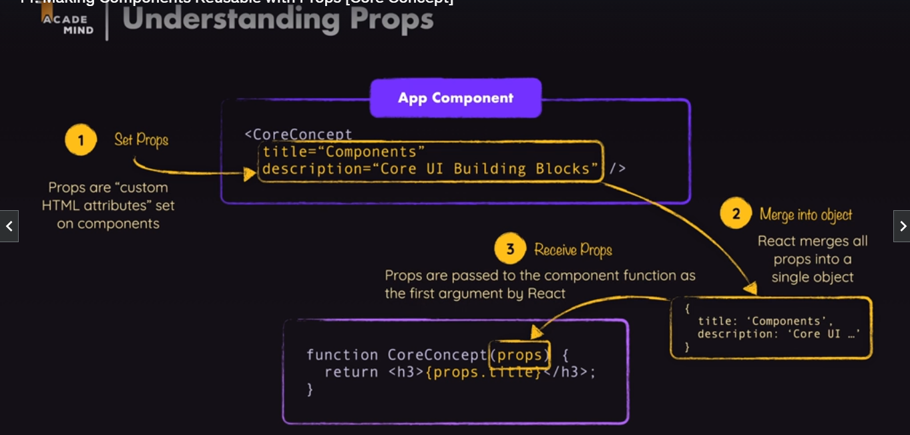

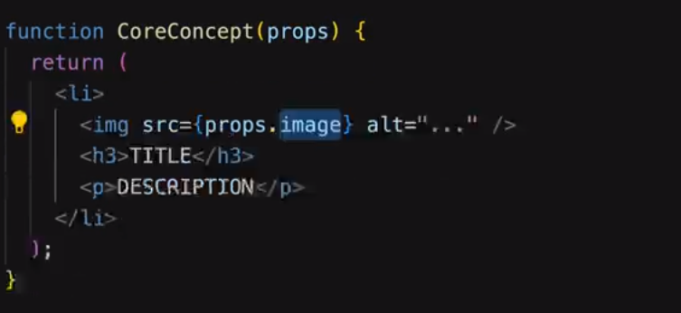

***props.img*** is used to get hold of the image ***ComponentsImg.***

